**IS4110 - Capstone Project Final Report**

**CLAWS**

**Cultivated Lands Animal Warning System**

***Submitted By:***

20APC4639 I.V.P.Wijethunga

20APC4572 A.S.G.S.Somasiri

20APC4660 M.Z.Muhammad

20APC4617 P.G.B.C.K.Somarathna

***Supervised By:***

Mrs.W.V.S.K.Wasalthilake

***Mentored By:***

Mr.Nuwanga Herath

Department of Computing & Information Systems

Faculty of Computing

Sabaragamuwa University of Sri Lanka

**Declaration**

We declare that this thesis does not incorporate, without acknowledgment, any material previously submitted for a Degree or a Diploma in any University, and to the best of our knowledge and belief, it does not contain any material previously published or written by another person or ourselves except where due reference is made in the text. Also, we hereby grant to Sabaragamuwa University of Sri Lanka the non-exclusive right to reproduce and distribute our thesis, in whole or in part in print, electronic, or other medium. We retain the right to use this content in whole or part in future works (such as articles or books).

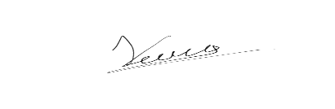Name of the Student Signature of Student

I.V.P. Wijethunga ………………………

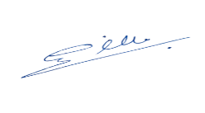

A.G.G.S. Somasiri ………………………



M.Z. Muhammad ………………………



P.G.B.C.K.Somarathna ………………………

Date: 2024.08.24

**Certificate of Approval**

We hereby declare that this thesis is from the student’s work and effort, and all other sources of information used have been acknowledged. This thesis has been submitted with our approval.

* **Mentor**

Mr**.** Nuwanga Herath

Software Engineer - Cut & Dry Inc.

25/08/2024 

Date: ………………………… Signature: …………………………

* **Internal Supervisor**

Mrs.W.V.S.K. Wasalthilake

Lecturer - Faculty of Computing

Sabaragamuwa University of Sri Lanka

Date: ………………………… Signature: …………………………

* **Head of the Department of Computing & Information Systems**

Dr. L.S.Lekamge

Senior Lecturer - Faculty of Computing

Sabaragamuwa University of Sri Lanka

Date: ………………………… Signature: …………………………

**Acknowledgment**

First and foremost, we would like to extend our deepest gratitude to Professor S. Vasanthapriyan, Dean of the Faculty of Computing at Sabaragamuwa University of Sri Lanka, for his invaluable support and continuous encouragement throughout the development of the "Animal Detection System in Cultivated Lands." The opportunities and resources provided by the Faculty have been instrumental in the successful completion of this project, and we are profoundly grateful for the unwavering support we have received. We sincerely thank the Department of Computing & Information Systems, Sabaragamuwa University of Sri Lanka, for fostering an environment that encourages innovation, technological advancement, and growth. Our special thanks go to Dr. L.S. Lekamge, Head of the Department of Computing & Information Systems, for her guidance, leadership, and encouragement, which have played a crucial role in shaping our approach and ensuring the project’s success. We are particularly indebted to our internal supervisor, Mrs. W.V. Subodhi Kalpani Wasalthilake, Lecturer in the Department of Computing & Information Systems, for her expert guidance, insightful advice, and unwavering support. Her mentorship has been fundamental in refining our project and ensuring that it meets the highest standards of quality and functionality. Our heartfelt thanks also go to our external mentor, Mr. Nuwanga Herath, a graduated software engineer at Cut & Dry Inc. His professional insights, practical advice, and consistent support have significantly contributed to the development and enhancement of our system. Furthermore, we extend our sincere gratitude to our seniors and friends for their steadfast support, encouragement, and valuable input throughout this journey. Their collaborative spirit and shared knowledge have greatly contributed to the refinement of our ideas and approaches, helping us to overcome challenges and achieve our goals. This project has provided us with a significant opportunity to apply our skills and innovative thinking in creating a cutting-edge solution for protecting agricultural lands. We are deeply appreciative of all those who have been a part of this journey, directly or indirectly. Your contributions have been essential in bringing this project to fruition and in advancing our understanding of how technology can positively impact sustainable agriculture.

Thank You,

Group 16.

**Abstract**

The "Cultivated Lands Animal Warning System" offers an innovative solution to mitigate the economic losses and food insecurity caused by wild animals damaging crops. Traditional control methods such as fencing and manual patrolling are labor-intensive and often ineffective. This project leverages IoT, Machine Learning, Artificial Intelligence, and Arduino technology to deliver an automated, real-time monitoring and deterrent system. IoT-enabled devices, including cameras and sensors, continuously monitor agricultural fields, capturing data that cloud-based ML models process to accurately detect and identify harmful animals. Upon detection, the system autonomously triggers deterrent actions, such as emitting specific frequencies, to prevent crop damage. The system has demonstrated high accuracy in identifying target animals and effectively reducing crop losses with minimal human intervention. These results suggest that the system can significantly improve agricultural productivity and sustainability. The project highlights the potential for integrating modern technologies into agriculture to enhance food security and economic stability for farmers. Future recommendations include scaling the system for broader applications and refining the ML models for even higher accuracy.

**Table of Contents**

**Chapter 1: Introduction** 1

**1.1 Major Goals and Objectives** 1

**1.2 Motivation** 3

**1.3 The Scope of the Completed Project** 4

**1.4 The Approach and Assumptions while Carrying Out the Project Work** 7

**1.5 Concise Summary of Major Outcomes** 9

**Chapter 2: Background** 11

**Chapter 3: Specification and Design** 13

**3.1 Specification** 13

**3.2 Design** 15

**3.2.1 Use Case Diagram** 15

**3.2.2 State Machine Diagram** 16

**3.2.3 Sequence Diagram** 17

**Chapter 4: Implementation** 18

**4.1 Software Hardware Requirements** 18

**4.1.1 Software Requirements** 18

**4.1.2 Hardware Requirements** 18

**4.2 System Architecture** 19

**4.2.1 IoT Device Layer** 19

**4.2.2 Cloud Layer** 22

**4.2.3. Application Layer** 23

**4.3 Implementation of Machine Learning Model** 28

**4.3.1 Data Collection and Pre-processing** 28

**4.3.2 Model Development and Training** 29

**4.4 System Integration** 31

**4.4.1 IoT and Cloud Integration** 31

**4.4.2. Mobile App Integration** 32

**4.5 Testing and Debugging** 33

**4.5.1 Unit Testing** 33

**4.5.2 Performance Testing** 34

**4.6 Challenges and Limitations** 34

**Chapter 5: Results and Evaluation** 36

**5.1 Experimental Results vs. Expected Results** 36

**5.2 Interrelationship of Experimental Results** 37

**5.3 Achieved Accuracy** 38

**5.4 Implications and Limitations** 38

**5.4.1 Implications** 38

**5.4.2 Limitations** 39

**Chapter 6: Future Work** 40

**Chapter7: Conclusion** 42

**References** 44

**Glossary** 45

**List of Figures**

Figure 1. Use Case Diagram 15

Figure 2. State Machine Diagram 16

Figure 3. Sequence Diagram 17

Figure 4. IoT Device Diagram 20

Figure 5. IoT Device Prototype 21

Figure 6. Cloud-Based Architecture 22

Figure 7. User Interface Overview 24

Figure 8. Prototype for the App 26

Figure 9. Prototype for the App 27

Figure 10. Sample Images from Training Dataset 29

Figure 11. Model Accuracy Figure 12. Model Loss 30

# **Chapter 1: Introduction**

Agriculture is the backbone of many economies, particularly in regions where a majority of the population relies on farming for their livelihood. However, one of the persistent challenges that farmers face is the threat posed by wild animals. These animals, ranging from large mammals like elephants and wild boars to smaller species of birds, can cause significant damage to crops. This not only results in economic losses but also threatens food security and the overall sustainability of agricultural practices.

Traditional methods of deterring animals from entering cultivated lands, such as manual monitoring, scarecrows, and physical barriers like fences, have proven to be either labor-intensive or insufficiently effective. As a result, there is an increasing demand for more advanced, automated solutions that can provide real-time monitoring and deterrence of wild animals in agricultural fields.

The "Cultivated Lands Animal Warning System" project was conceived in response to this pressing need. By integrating modern technologies such as the Internet of Things (IoT), Machine Learning (ML), Artificial Intelligence (AI), and cloud computing, this project aims to create a comprehensive system that can detect the presence of animals in real time, identify them accurately, and trigger appropriate deterrent mechanisms to prevent crop damage. The system is designed to be user-friendly, energy-efficient, and adaptable to various agricultural environments.

This project not only addresses the immediate challenge of crop protection but also contributes to the broader goal of sustainable agriculture. By minimizing crop losses, the system helps to ensure food security and improve the economic stability of farming communities. Furthermore, it reduces the need for harmful practices like poisoning or culling of animals, thereby promoting a more harmonious coexistence between humans and wildlife.

## **1.1 Major Goals and Objectives**

The primary goal of the "Cultivated Lands Animal Warning System" project is to develop an advanced, automated solution that effectively addresses the issue of crop damage caused by wild animals. This project aims to harness the power of IoT, Machine Learning, and Artificial Intelligence to create a system that not only detects the presence of animals in real-time but also accurately identifies the species and triggers appropriate deterrent mechanisms. By doing so, the project seeks to minimize the economic losses suffered by farmers and promote sustainable agricultural practices.

The specific objectives of the project include:

* **Designing and Implementing a Sensor-Based IoT Network:**  
  The first objective is to establish a robust IoT network that continuously monitors cultivated lands for animal intrusions. This network will be equipped with high-resolution cameras and motion sensors strategically placed throughout the agricultural fields. The data collected by these sensors will be transmitted in real-time to a cloud-based processing platform.
* **Developing an Accurate Machine Learning Model:**  
  A key objective is to create a machine learning model capable of accurately identifying different animal species based on the data collected by the IoT devices. This model will be trained using a comprehensive dataset and will employ advanced image processing techniques to ensure high accuracy in animal detection.
* **Creating a Real-Time Alert System:**  
  To enable timely interventions, the project aims to develop a real-time alert system that notifies farmers of any detected animal presence. This system will be integrated into a user-friendly mobile application, allowing farmers to receive instant notifications and monitor the status of their fields remotely.
* **Implementing an Automated Deterrent Mechanism:**  
  The project includes the development of an automated deterrent system that is activated upon the detection of specific animals. Depending on the identified species, the system will trigger appropriate deterrents, such as sound alarms or lights, to scare the animals away and prevent them from causing damage to the crops.
* **Ensuring Energy Efficiency and Remote Operability:**  
  Given that many agricultural fields are located in remote areas with limited access to electricity, the project emphasizes the importance of energy efficiency. The system is designed to operate using sustainable energy sources, such as solar power, to ensure continuous functionality even in off-grid locations.
* **Providing a Scalable and Cost-Effective Solution:**  
  The project also aims to create a system that is both scalable and cost-effective, making it accessible to farmers in various regions and adaptable to different types of crops. The solution should be affordable for small-scale farmers while still offering the robustness and reliability needed for larger agricultural operations.

By achieving these objectives, the project seeks to significantly reduce crop losses caused by wild animals, thereby enhancing agricultural productivity and improving the livelihoods of farmers. Additionally, the system’s adaptability and scalability mean that it has the potential to be deployed in various agricultural settings worldwide, contributing to global efforts in sustainable farming and food security.

## **1.2 Motivation**

The motivation behind the "Cultivated Lands Animal Warning System" project stems from the pressing need to address the significant challenges faced by farmers due to crop damage caused by wild animals. Across the globe, especially in regions where agriculture is a primary source of livelihood, the intrusion of wild animals into cultivated fields poses a serious threat to agricultural productivity. The financial losses incurred by farmers are substantial, often leading to reduced income, increased poverty, and, in extreme cases, food insecurity.

Traditional methods of protecting crops, such as fencing, manual monitoring, and the use of scarecrows or other scare tactics, have proven to be inadequate in effectively deterring wild animals. These methods are not only labor-intensive but also fail to offer the precision and reliability needed to protect large-scale agricultural operations. In many instances, these traditional approaches result in a continuous cycle of damage and repair, further exacerbating the financial strain on farmers.

In addition to the economic impact, the human-wildlife conflict that arises from these encounters often leads to negative consequences for both parties. Farmers may resort to harmful measures to protect their crops, such as trapping or poisoning animals, which can have detrimental effects on local ecosystems and biodiversity. Conversely, the intrusion of animals into human-dominated landscapes can result in injury or death to the animals, further highlighting the need for a more humane and effective solution.

The rapid advancements in technology, particularly in the fields of IoT, Machine Learning, and Artificial Intelligence, offer new opportunities to tackle this age-old problem. By leveraging these technologies, it is possible to develop a system that not only detects and identifies animals in real-time but also minimizes human intervention and maximizes efficiency. The use of automated systems can significantly reduce the time and effort required to monitor and protect crops, allowing farmers to focus on other essential aspects of their work.

The motivation for this project also aligns with broader global goals, such as promoting sustainable agriculture, reducing food waste, and enhancing food security. By preventing crop losses due to animal intrusions, this system can contribute to increased agricultural productivity, which is crucial for feeding a growing global population. Moreover, the project emphasizes the importance of coexisting with wildlife, by providing non-lethal deterrent methods that ensure the safety and well-being of both the animals and the farmers.

Another key motivating factor is the potential for this system to be adapted and scaled to different regions and types of crops. The flexible and modular design of the system means that it can be customized to meet the specific needs of various agricultural environments, from small family farms to large commercial operations. This adaptability ensures that the benefits of the system can be extended to a wide range of users, making it a valuable tool for improving agricultural practices worldwide.

In summary, the motivation for the "Cultivated Lands Animal Warning System" project is driven by the need to provide a modern, efficient, and humane solution to the problem of crop damage caused by wild animals. By integrating cutting-edge technology with practical agricultural applications, this project aims to improve the livelihoods of farmers, protect valuable crops, and promote a more sustainable and harmonious relationship between humans and wildlife.

## **1.3 The Scope of the Completed Project**

The "Cultivated Lands Animal Warning System" project encompasses a comprehensive range of activities, from the initial conceptualization and design to the development, deployment, and evaluation of the system. The scope of the project is extensive, addressing both the technical and practical aspects required to create a functional and effective solution for preventing crop damage caused by wild animals. The following key components outline the scope of the completed project:

**Design and Development of IoT-Enabled Detection System**

The first major component of the project involves the design and development of an IoT-enabled detection system. This system includes the deployment of high-resolution cameras, motion sensors, and other IoT devices that are strategically placed throughout cultivated fields. These devices continuously monitor the environment, capturing real-time data on animal activity. The design process also involved ensuring that these devices are robust, weather-resistant, and capable of functioning in various environmental conditions typical of agricultural settings. The development phase focused on integrating these devices into a cohesive network that could reliably transmit data to the cloud-based processing platform.

**Implementation of Cloud-Based Data Processing Platform**

The second component of the project is the implementation of a cloud-based data processing platform. This platform is responsible for analyzing the data collected by the IoT devices using advanced machine learning algorithms. The system was designed to detect and identify different animal species based on the images and sensor data captured. The platform leverages cloud computing resources to perform real-time processing, ensuring that alerts and deterrent actions can be triggered immediately upon detection. The implementation also included setting up a scalable infrastructure capable of handling large volumes of data and supporting future enhancements or expansions of the system.

**Development of a Mobile Application for Farmers**

The third key aspect of the project is the development of a mobile application designed specifically for farmers. This application serves as the primary interface between the farmers and the detection system. Through the mobile app, farmers receive real-time alerts about detected animal activity, allowing them to take immediate action to protect their crops. The app also provides users with the ability to monitor the status of the system, control deterrent mechanisms, and access historical data on animal intrusions. The user interface was carefully designed to be intuitive and user-friendly, ensuring that it can be easily used by individuals with varying levels of technical literacy.

**Integration of Automated Deterrent Mechanisms**

An important part of the project’s scope includes the integration of automated deterrent mechanisms that are activated when animals are detected. These mechanisms, which may include auditory and visual deterrents, are designed to scare away animals without causing them harm. The integration process involved ensuring that these deterrents are effective for the specific animal species identified by the system. Additionally, the project explored the potential for adapting these deterrent strategies based on feedback and data collected during field tests, to enhance their effectiveness over time.

**Field Testing and Evaluation**

The scope of the project included extensive field testing and evaluation under various environmental conditions. The system was deployed across multiple test sites, each with different crop types and varying levels of animal activity, to rigorously assess its performance in real-world scenarios. Key evaluation metrics included system accuracy, processing load, and testing time. The accuracy of animal detection was measured to ensure that the system could reliably identify and respond to threats. The processing load was monitored to determine the system's efficiency and capability to handle real-time data without significant delays. Testing time was carefully recorded to evaluate the speed at which the system could detect animals and activate deterrents. Additionally, the effectiveness of the deterrent mechanisms was assessed by observing the overall reduction in crop damage. Feedback from farmers who participated in the field tests was gathered and utilized to make iterative improvements, ensuring that the system met practical agricultural needs.

**Impact Analysis and Future Potential**

Finally, the project scope includes an analysis of the system’s impact on reducing crop losses and its potential for future expansion. The impact analysis focused on quantifying the reduction in crop damage, assessing the system’s ease of use, and evaluating its acceptance by the farming community. The project also identified potential areas for future development, such as expanding the system to support additional animal species, integrating more advanced AI algorithms, or developing new types of deterrent mechanisms. The adaptability and scalability of the system ensure that it can be customized to meet the needs of different agricultural regions and environments, making it a valuable tool for farmers worldwide.

**Consideration of Environmental and Economic Factors**

Throughout the project, consideration was given to both environmental and economic factors. The system was designed to be energy-efficient, utilizing sustainable power sources where possible, and minimizing its environmental footprint. The cost-effectiveness of the system was also a critical consideration, ensuring that it can be accessible to farmers with limited financial resources. The project’s scope includes the exploration of potential funding or subsidy opportunities that could further reduce the cost burden on farmers, making the technology more widely available.

**Documentation and Knowledge Transfer**

The scope of the project also includes comprehensive documentation and knowledge transfer. Detailed technical documentation was created to support future enhancements or troubleshooting efforts. Additionally, training materials were developed to assist farmers in using the system effectively. The knowledge transfer process ensures that the system can be maintained and supported in the long term, even as new technologies or methods become available.

## **1.4 The Approach and Assumptions while Carrying Out the Project Work**

**Approach**

The development of the Cultivated Lands Animal Warning System Lands was carried out through a structured and systematic approach, encompassing several phases to ensure comprehensive coverage and effective implementation. The approach involved the following stages:

* **Requirement Analysis**: Initial requirements were gathered through consultations with stakeholders, including farmers and agricultural experts. This phase involved understanding the specific needs related to animal intrusion, the types of animals commonly found in cultivated lands, and the environmental conditions affecting the system's performance.
* **System Design**: Based on the requirements, a detailed system design was created. This included the selection of hardware components (e.g., microcontroller, camera, speaker) and software tools (e.g., TensorFlow, OpenCV2). The design phase also involved creating architectural diagrams, data flow diagrams, and defining the interactions between different system components.
* **Development and Integration**: The development phase involved coding the machine learning models for animal detection using Python, and developing the mobile application frontend using Flutter. Integration of the hardware components with the software was carried out using Arduino IDE for IoT device control. Continuous testing was performed during this phase to ensure that each component functioned correctly both individually and as part of the overall system.
* **Testing and Validation**: Extensive testing was conducted to validate the system's performance. This included field tests to evaluate the accuracy of animal detection, the effectiveness of deterrent actions, and the reliability of data transmission between the sensors and the cloud infrastructure. Adjustments and improvements were made based on test results to enhance system accuracy and functionality.
* **Documentation and Reporting**: The final phase involved compiling the results and preparing comprehensive documentation. This included the project report, which covers the implementation details, experimental results, and future work recommendations.

**Assumptions**

Several assumptions were made during the project to ensure its feasibility and to streamline the development process:

* **Hardware Reliability**: It was assumed that the selected hardware components (microcontroller, camera, speaker, etc.) would function reliably under the environmental conditions typical of cultivated lands. The durability of these components was considered adequate for long-term use.
* **Stable Network Connectivity**: The system assumes a stable network connection for IoT data transmission. It was expected that the network infrastructure in the agricultural areas would support uninterrupted data flow between the sensors and the cloud.
* **Animal Behavior**: The project assumes that the behavior of the animals in the cultivated lands would be consistent with the scenarios anticipated during the design phase. Variations in animal behavior or new animal species not considered during the design might affect the system's performance.
* **Cloud Infrastructure Performance**: It was assumed that the cloud infrastructure, including storage and processing capabilities, would be sufficient to handle the data generated by the system. The system was designed with the assumption that cloud services would be available and operational throughout the project lifecycle.
* **User Engagement**: The project assumes that end-users (farmers) will engage with the system as intended, including setting up the hardware and interacting with the mobile application. User training and support were considered necessary to ensure proper use and effectiveness.

By adhering to this approach and considering these assumptions, the project aimed to develop a robust and effective Animal Detection System capable of addressing the challenges faced by farmers in protecting their crops from wildlife intrusions.

## **1.5 Concise Summary of Major Outcomes**

The Cultivated Lands Animal Warning System project yielded significant outcomes, demonstrating its potential to address key issues related to wildlife intrusion and crop protection. The major outcomes are as follows:

* **Enhanced Animal Detection Accuracy**: The deep learning models employed in the system achieved notable accuracy in identifying various animal species. Leveraging TensorFlow and OpenCV2, the models were trained on a comprehensive dataset, enabling real-time detection with high precision. The system effectively distinguished between different animal species and reduced false positives, ensuring reliable identification.
* **Efficient Deterrent Actions**: The integration of a high-quality speaker with the detection system enabled the successful implementation of deterrent mechanisms. Once an animal was detected, the system activated species-specific deterrent actions, such as sound alerts, to repel the animals and prevent them from causing damage. This approach proved effective in reducing the frequency of animal intrusions and protecting crops.
* **Robust IoT Integration and Data Transmission**: The IoT components, including the microcontroller and sensors, were integrated seamlessly with the system. The stable data transmission from the field to the cloud infrastructure ensured real-time monitoring and prompt response to detected intrusions. The system maintained a reliable network connection, which was crucial for the timely operation of the animal detection and deterrent processes.
* **User-Friendly Mobile Application**: The mobile application developed using Flutter provided a user-friendly interface for farmers. It allowed users to monitor system status, receive real-time alerts, and adjust settings easily. The application’s design focused on simplicity and usability, ensuring that users could interact with the system effectively without extensive technical knowledge.
* **Comprehensive Field Testing**: The system underwent rigorous field testing to validate its performance in real-world conditions. The tests covered various environmental scenarios and different animal behaviors, confirming the system's reliability and effectiveness in diverse settings. The results demonstrated that the system met its objectives of minimizing crop damage and supporting sustainable agricultural practices.
* **Scalable and Adaptable Design**: The system's architecture was designed with scalability in mind, enabling potential expansion to larger areas or additional functionalities in the future. The modular design of hardware and software components allows for easy upgrades and integration of new features, ensuring that the system can evolve to meet future needs and challenges.
* **Positive Impact on Agricultural Practices**: The project successfully addressed the challenge of wildlife intrusion, providing farmers with a practical solution to protect their crops. The reduction in economic losses and the enhanced sustainability of agricultural practices were significant outcomes, demonstrating the system's value and impact on the agricultural sector.

# **Chapter 2: Background**

The increasing interaction between wildlife and agricultural activities has become a pressing issue, leading to substantial crop damage and posing a significant threat to food security and farmers' livelihoods. Traditional methods of mitigating this problem, such as manual monitoring, fences, and scarecrows, have proven inadequate. These methods often require significant labor and fail to provide timely or effective intervention, making them insufficient in the face of modern agricultural challenges. As a result, there is a growing need for innovative solutions that leverage modern technology to protect crops more efficiently.

The "Cultivated Lands Animal Warning System" project was initiated in response to this growing need. Farmers across various agricultural regions face ongoing struggles to prevent wild animals from entering their fields, which results in significant crop losses. The economic impact of such losses can be devastating, affecting not only individual farmers but also the broader agricultural economy. As the global population continues to grow, ensuring reliable food production becomes increasingly critical, and protecting crops from wildlife is an essential aspect of this effort.

In addition to the economic implications, there are environmental and sustainability concerns associated with traditional crop protection methods. The use of chemical deterrents and physical barriers can have negative environmental impacts, making it imperative to explore more sustainable alternatives. The project aims to provide a solution that not only detects the presence of animals in agricultural fields but also offers immediate and non-invasive deterrent actions, reducing the reliance on harmful practices and minimizing human-wildlife conflict. By doing so, the project seeks to preserve both crops and wildlife, promoting a more harmonious coexistence between agriculture and nature.

The concept of using technology to protect crops from wildlife is not new, but recent advancements in IoT and machine learning have opened up new possibilities. Various projects have explored the use of IoT devices to monitor agricultural fields, yet few have focused specifically on animal detection and deterrence. Research in the field of machine learning has demonstrated that models can be trained to recognize different animal species based on sensor data, although the accuracy and reliability of these models can vary. Existing solutions often rely on static deterrents, such as noise, which can lose effectiveness over time as animals become accustomed to them. Therefore, the development of dynamic and adaptive deterrent mechanisms is an area of active research, and this project aims to contribute to this evolving field by implementing more effective, real-time solutions that address the limitations of previous efforts.

In summary, the "Cultivated Lands Animal Warning System" project represents a forward-thinking approach to a longstanding problem in agriculture. By leveraging modern technologies and addressing the shortcomings of traditional methods, the project aims to create a more effective and sustainable solution for protecting crops from wildlife, ultimately contributing to food security, economic stability, and environmental conservation.

# **Chapter 3: Specification and Design**

## **3.1 Specification**

The "Cultivated Lands Animal Warning System" is designed to detect and deter animals that may cause damage to agricultural fields. This system is implemented using a combination of hardware and software components that work together to achieve real-time monitoring and response. The following specifications outline the system's key features and requirements.

**Automated Animal Detection and Identification**

* **Real-time Monitoring:** The system continuously monitors the agricultural field using IoT-enabled cameras and sensors.
* **Image Capture and Processing:** The system captures images of any detected movement using a 2MP camera module. It processes the captured images with deep learning models to accurately identify the species of the intruding animals.
* **Detection Accuracy:** The system achieves high detection accuracy by leveraging convolutional neural networks (CNN) trained specifically for identifying animals common to the region.

**IoT Integration and Control**

* **Microcontroller Interface:** The system uses a microcontroller with built-in Wi-Fi and Bluetooth capabilities to interface with various sensors and actuators.
* **Wireless Communication:** The microcontroller transmits data to the cloud and receives commands from the control system via a reliable network connection, ensuring real-time communication.
* **Actuation Mechanism:** Upon identifying an animal, the system triggers deterrent actions (e.g., emitting specific frequencies through speakers) to scare away the animal.

**Cloud-based Data Processing and Storage**

* **Data Upload:** The system uploads captured images and sensor data to a cloud-based storage system for processing and long-term storage.
* **Machine Learning Model Execution:** The cloud infrastructure hosts machine learning models that analyse the data and provide real-time decisions on the type of animal detected and the appropriate deterrent action.
* **Scalability:** The cloud environment scales to accommodate varying data loads, ensuring the system's reliability in larger or more active fields.

**Mobile Application for Monitoring and Management**

* **User Interface:** The system provides a mobile application developed using Flutter, enabling users to monitor real-time data, view alerts, and manage settings.
* **Alerts and Notifications:** Users receive instant notifications on their mobile devices when the system detects an animal and triggers a deterrent action.
* **Remote Access:** The mobile application allows users to access historical data remotely, review system performance, and update system parameters.

**System Reliability and Power Management**

* **Uninterruptible Power Supply:** The system uses a battery as the power supply, which recharges via a solar panel.
* **Backup Mechanism:** The system employs secondary storage with a 4GB capacity to store data temporarily in case of network failures, ensuring no data loss.
* **Hardware Durability:** All hardware components are robust and capable of withstanding outdoor environmental conditions.

**Security and Data Integrity**

* **Secure Communication:** The system encrypts data transmitted between the microcontroller, cloud, and mobile application to ensure data integrity and prevent unauthorized access.
* **User Authentication:** The mobile application implements secure user authentication mechanisms, such as username and password.

## **3.2 Design**

### **3.2.1 Use Case Diagram**

Figure 1. Use Case Diagram

The Use Case Diagram illustrates the interactions between the End User and Device with the Cultivated Lands Animal Warning System. This system is designed to monitor animal behavior in cultivated lands, send alerts, and allow for manual and automatic responses. The diagram identifies the key functionalities available to the end users and how these functions interact with the system.

### **3.2.2 State Machine Diagram**

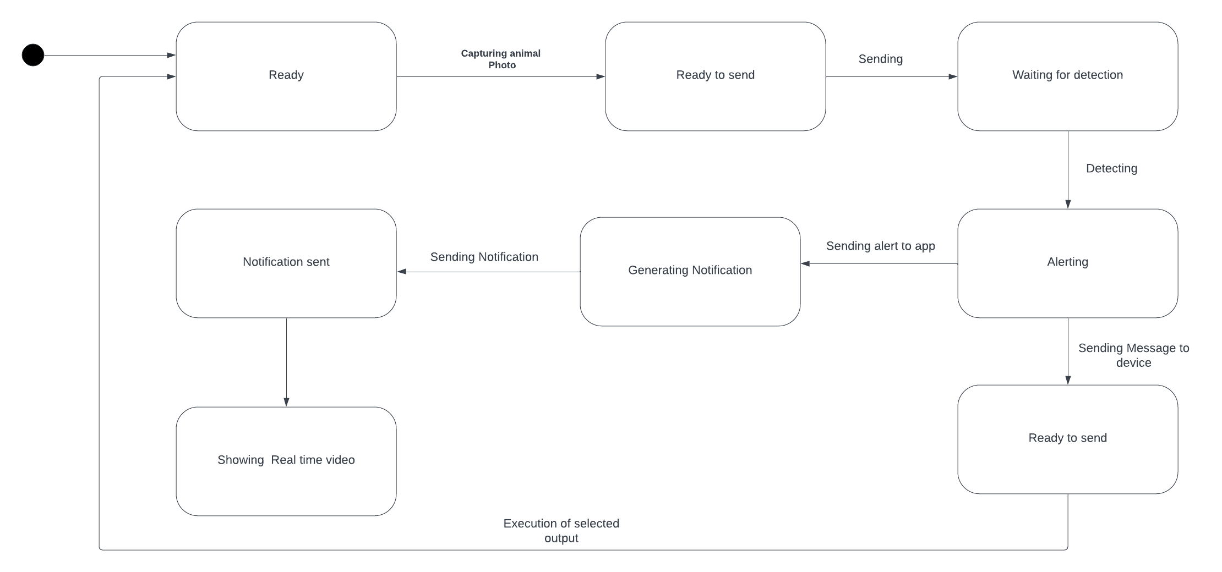

Figure 2. State Machine Diagram

This State Machine Diagram illustrates the workflow of this system. The process begins with the system in a "Ready" state, where it is prepared to capture an animal's photo. Once a photo is captured, the system transitions to the "Ready to send" state, indicating that the data is prepared for transmission. The photo is then sent, leading to the "Waiting for detection" state, where the system anticipates the detection of the animal. Upon detecting the animal, the system moves to the "Alerting" state, where it sends an alert to the corresponding application. This is followed by the generation of a notification, which is then sent to the user’s device. The final stages include showing a real-time video feed and executing the selected output, which completes the system's cycle. The system then loops back to the "Ready" state, awaiting the next capture.

### **3.2.3 Sequence Diagram**

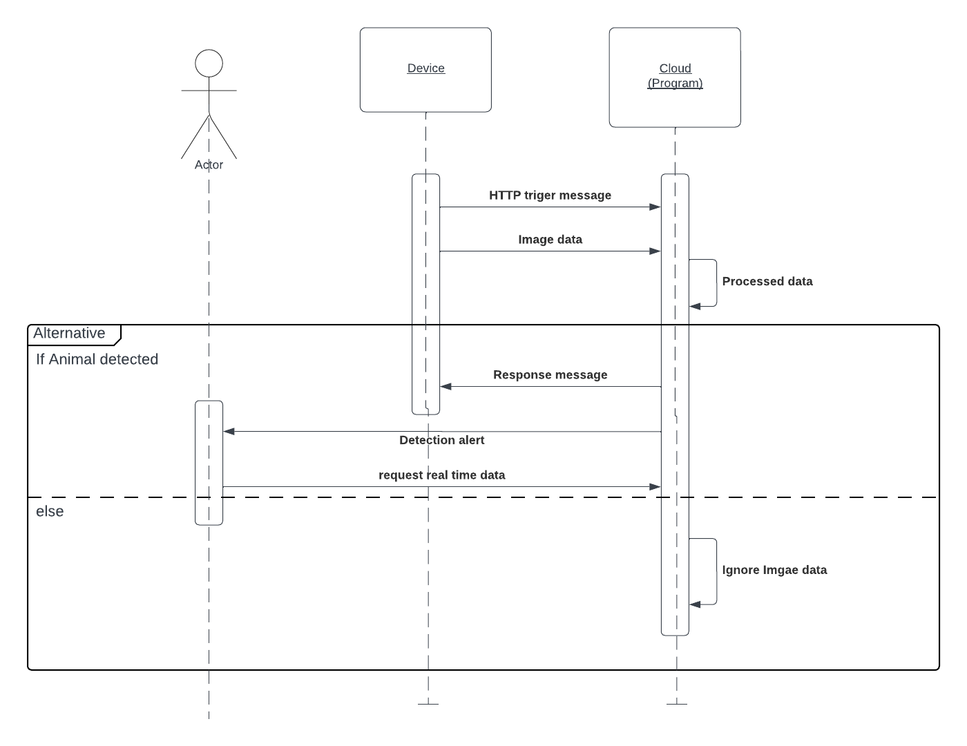

Figure 3. Sequence Diagram

The Sequence Diagram provides a step-by-step representation of the interaction between various components of the Cultivated Lands Animal Warning System when an animal is detected in cultivated lands. This diagram highlights the communication flow among the Actor (end-user), Device, and Cloud (Program).

# **Chapter 4: Implementation**

## **4.1 Software Hardware Requirements**

### **4.1.1 Software Requirements**

• **Programming Languages and Frameworks**:

* **Python**: For machine learning model development and backend logic
* **Flutter / Swift**: For mobile application frontend development
* **Arduino Wiring Framework**: For IoT device control programs

• **Deep Learning and Image Processing Libraries**:

* **OpenCV2**: For image processing and analysis
* **TensorFlow**: For building and training deep learning models
* **Pandas & Matplotlib**: For data processing and feature extraction

• **Database**:

* Firebase Real-Time Database / Google Cloud Storage

• **Version Control**:

* **Git**: For collaborative development and code versioning

• **Integrated Development Environments (IDEs)**:

* **Google Colab, Jupyter Notebook, PyCharm**: For machine learning model development and backend implementation
* **Android Studio / VS Code / X Code**: For mobile app development
* **Arduino IDE**: For IoT device programming

### **4.1.2 Hardware Requirements**

**IoT Device**

* Esp 32 cam.module
* Esp32 cam development kit
* Esp32 Wroom module
* PIR sensor
* DAC amplifier
* SD card module
* Speaker
* Micro SD card
* 4GB storage
* 5V DC power supply
* FTDI adapter
* Jumper wires
* Uninterrupted network connection for real-time data transmission

**Cloud Infrastructure**:

* 4+ Core CPUs with 2.5GHz clock speed
* 4GB+ RAM
* 256GB Cloud storage for data management and model deployment

## **4.2 System Architecture**

### **4.2.1 IoT Device Layer**

The IoT Device Layer of the "Cultivated Lands Animal Warning System" is a critical component that facilitates real-time monitoring and detection of animals in agricultural fields. This layer consists of several interconnected devices, each playing a specific role in the system’s functionality. The architecture of the IoT Device Layer is designed to ensure seamless data collection, processing, and communication between the field sensors and the cloud-based machine learning models.

**Component Overview**

* **ESP32-CAM Module**: The ESP32-CAM module serves as the primary imaging device within the system. It captures high-resolution images of the field and any detected animals. This module is equipped with a 2MP OV2640 camera, capable of taking clear pictures even in low-light conditions. The captured images are then processed locally or transmitted to the cloud for further analysis.
* **Passive Infrared (PIR) Sensor**: The PIR sensor detects motion within the field. When an animal enters the detection zone, the sensor triggers the ESP32-CAM to capture an image. The PIR sensor is crucial for minimizing power consumption, as it only activates the camera when motion is detected.
* **Speaker Module**: The speaker is connected to the IoT system to deliver auditory deterrents. When the system identifies a potential threat (such as an animal entering the field), it can play pre-recorded sounds through the speaker to scare away the intruder.
* **BME280 Sensor**: The BME280 sensor monitors environmental conditions, including temperature, humidity, and atmospheric pressure. This data is valuable for understanding the environmental context of animal movements and can be used to enhance the accuracy of detection algorithms.
* **MicroSD Card Adapter**: The MicroSD card adapter is used for local storage of images and environmental data. This ensures that data is not lost if the network connection is interrupted and provides a backup that can be accessed later for analysis.

**IoT Device Integration**

The components are integrated through the ESP32 microcontroller, which acts as the central hub of the IoT Device Layer. The microcontroller manages communication between the sensors, camera, and other peripherals, ensuring that the system operates efficiently. The ESP32 is chosen for its powerful processing capabilities, built-in Wi-Fi and Bluetooth, and compatibility with various sensors and modules.

The provided schematic diagram (as shown in Figure 4) illustrates the interconnections between these components. The ESP32-CAM is connected to the PIR sensor, which provides the trigger signal for image capture. The captured images are stored locally on the MicroSD card and can be transmitted to the cloud for further processing. The BME280 sensor continuously monitors environmental conditions, and the speaker is used to issue deterrent sounds based on detection outcomes.

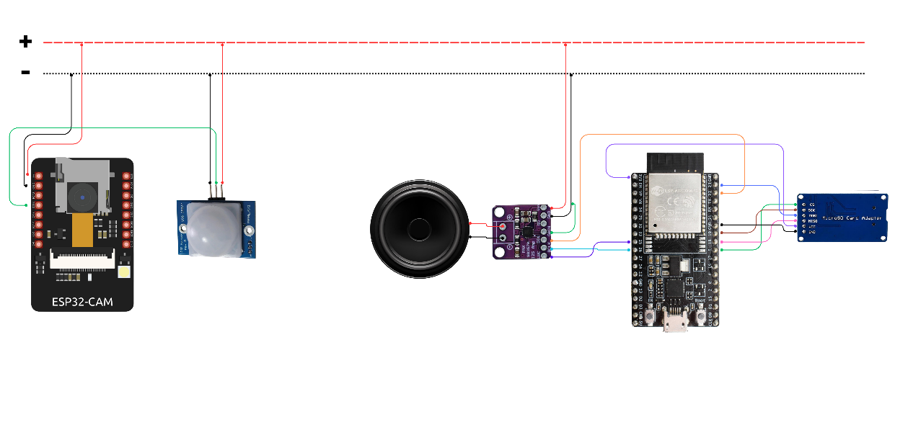

Figure 4. IoT Device Diagram

**Operation Workflow**

1. **Detection Trigger**: The PIR sensor detects motion in the field and signals the ESP32-CAM to capture an image.
2. **Data Capture**: The ESP32-CAM captures the image and stores it on the MicroSD card. Environmental data from the BME280 sensor is also recorded.
3. **Data Transmission**: If a network connection is available, the image and environmental data are transmitted to the cloud-based machine learning model for analysis.
4. **Action Response**: Based on the analysis, if an animal is detected, the system triggers the speaker to emit deterrent sounds, scaring the animal away from the crops.

This layered approach ensures that the system is robust, energy-efficient, and capable of operating in diverse environmental conditions. The IoT Device Layer is the backbone of the system, enabling real-time detection and response to potential threats to cultivated lands.

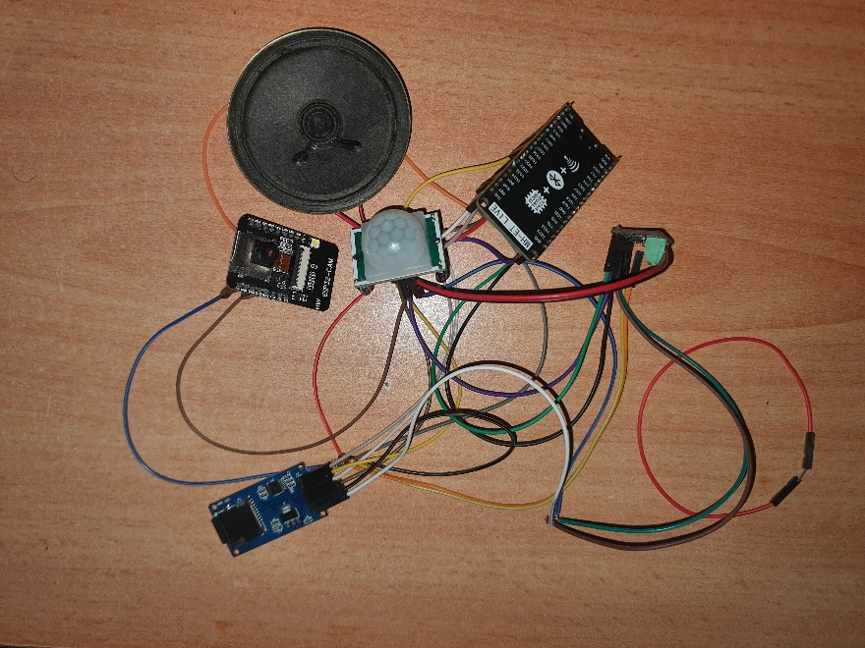

Figure 5. IoT Device Prototype

### **4.2.2 Cloud Layer**

The Cloud Layer is the backbone of the Cultivated Lands Animal Warning System, providing a powerful and scalable infrastructure that supports the real-time processing, storage, and analysis of data collected from the IoT devices deployed in the fields. The architecture, hosted on **Google Cloud**, is designed to handle large volumes of data, ensure seamless communication between various system components, and deliver quick, reliable responses essential for preventing crop damage.

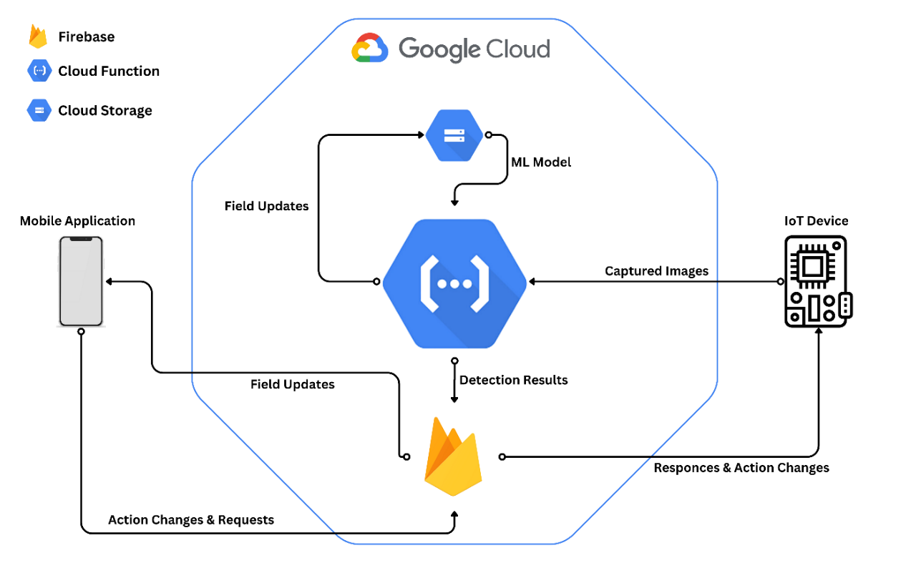

Figure 6. Cloud-Based Architecture

**Core Components of the Cloud Layer**

* **Serverless Computing with Google Cloud Functions**

At the heart of the cloud layer lies **Google Cloud Functions**, a serverless platform that allows the system to run backend code without the need for managing servers. Cloud Functions are triggered by events, such as the arrival of new data from IoT devices, and perform critical tasks like processing images, applying machine learning models for animal detection, and sending real-time alerts to the farmers via the application layer. This serverless approach not only scales automatically to handle varying workloads but also reduces operational complexity, enabling the system to respond swiftly to animal intrusions.

* **High-Availability Storage with Google Cloud Storage**

**Google Cloud Storage** serves as the secure and scalable repository for all data generated by the system, including images captured by cameras and sensor readings from the fields. This storage solution is built to handle the demands of big data, providing high durability and accessibility. With Cloud Storage, the system ensures that all collected data is readily available for analysis by Cloud Functions, enabling real-time decision-making processes. This robust storage infrastructure plays a crucial role in maintaining the system's reliability and performance.

* **Real-Time Data Synchronization with Firebase**

The **Firebase** database, integrated within the cloud layer, acts as a real-time NoSQL database that stores critical information, such as user profiles, animal detection logs, and system status updates. Firebase enables seamless synchronization between the cloud and the mobile application, ensuring that farmers have access to the latest data and alerts. This real-time database is essential for maintaining consistent communication and data flow, making it possible for the system to provide timely interventions to prevent crop damage.

* **Seamless Integration with Google Cloud Platform (GCP)**

The entire cloud layer is built upon the robust infrastructure of **Google Cloud Platform (GCP)**, which offers a suite of services that support the deployment, management, and scaling of the system. GCP’s global network ensures low-latency communication between the cloud, IoT devices, and mobile application, making the system highly responsive regardless of the user's location. The integration with GCP also provides advanced analytics capabilities and the computational power needed to run complex machine-learning models for accurate animal detection.

### **4.2.3. Application Layer**

The Application Layer in the "Cultivated Lands Animal Warning System" is designed to provide a user-friendly interface that allows farmers and field operators to interact with the system efficiently. This layer is crucial for monitoring, controlling, and managing the detection system, ensuring that the necessary actions are taken promptly based on the real-time data provided by the IoT devices and processed through the Cloud Layer.

**User Interface Overview**

The Application Layer consists of a mobile application that offers an intuitive interface for users. The application is divided into several key components, each designed to provide specific functionalities.

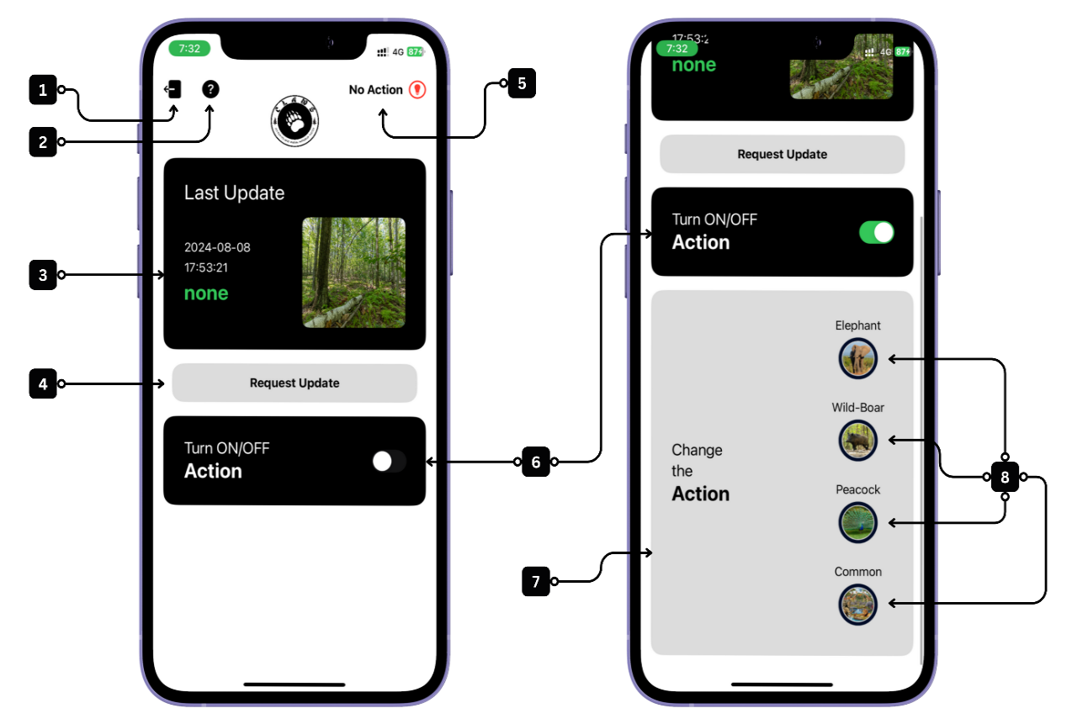

Figure 7. User Interface Overview

**Log out of the Application (1)** :Located at the top left of the screen, this button allows users to securely log out of the application. The log-out process is linked to Firebase authentication, ensuring that the user's session is terminated and their data is protected.

**App Guide (2)** :Positioned next to the log-out option, the App Guide provides users with a comprehensive tutorial on how to navigate and use the application. It includes instructions on the app's various components and guides on how to interact with the features, ensuring that even first-time users can operate the app effectively.

**Last Update Information (3)** :This section displays the latest update from the system, including an image captured in the field. It provides crucial details such as the date and time of the capture, and identifies the animal in the image (e.g., Elephant, Wild Boar, Peacock). If no animal is detected, the label "Common" is displayed. This feature ensures that users are always informed about the most recent activities in the monitored area.

**Update Request Button (4)**:Located below the Last Update Information, this button allows users to manually request the latest update from the system. By pressing this button, the application fetches the most recent data from the field, ensuring real-time monitoring and control.

**No Action Indicator(5)**:This indicator, found at the top right of the screen, informs the user whether any action is currently being taken by the system. It serves as a quick reference for users to verify if the deterrent mechanisms are active or if the system is in a passive state.

**Action Toggle Button(6)** :This toggle switch enables users to manually activate or deactivate the system's deterrent actions. When turned on, the system will automatically respond to detected animals based on the predefined settings. This feature offers users control over when the system should engage its protective measures.

**Animal Change Option (7)** :If the system's detection is incorrect, users can manually change the identified animal. This feature, located in the main interface, ensures that the system's records remain accurate. Users can select the correct animal from the provided options (Elephant, Wild Boar, Peacock, or None).

**Manual Animal Selection (8)** :This component allows users to manually choose the animal type from four options: Elephant, Wild Boar, Peacock, and Common. This functionality is useful in cases where the user wants to override the system's automatic detection or in scenarios where the system's identification needs correction.

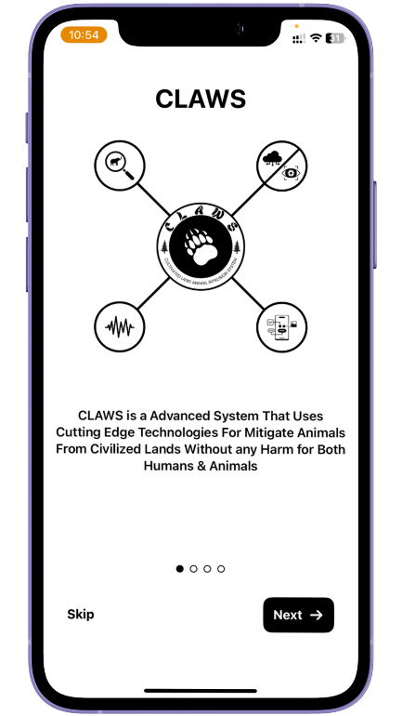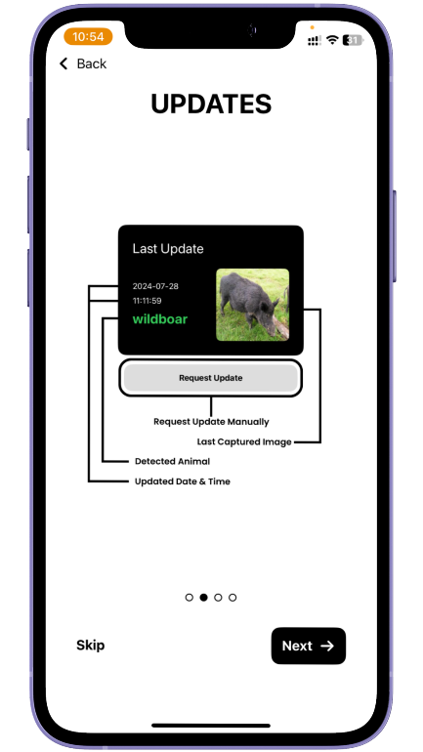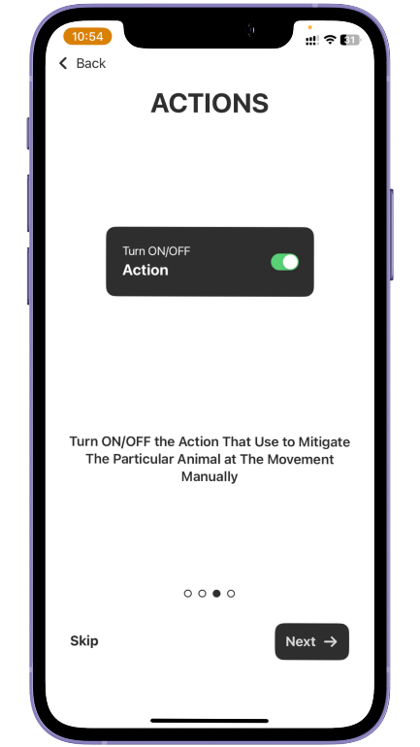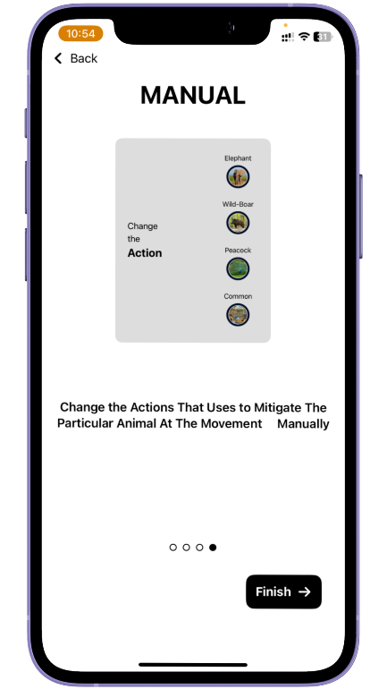

Figure 8. Prototype for the App

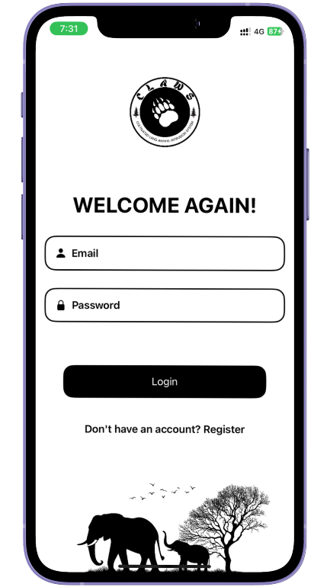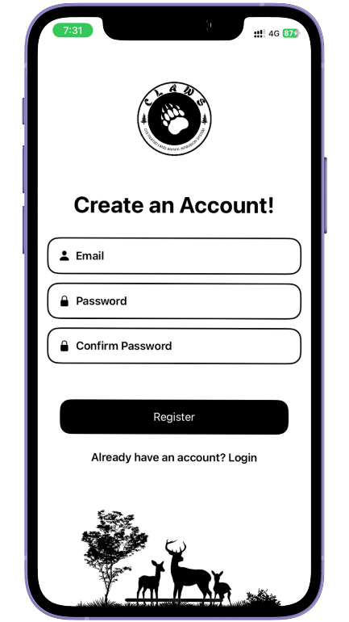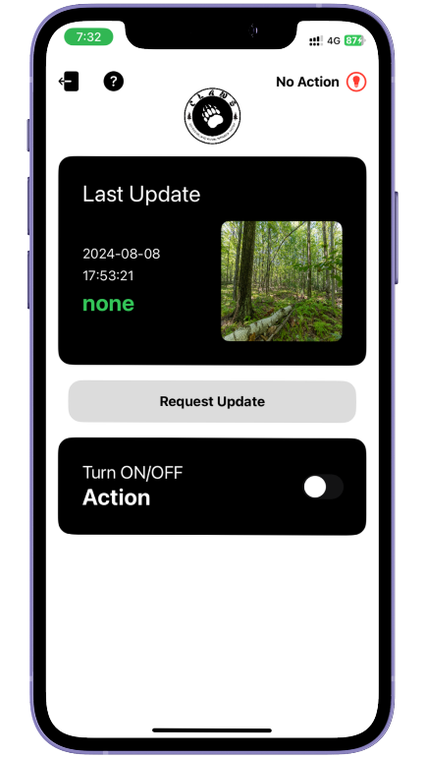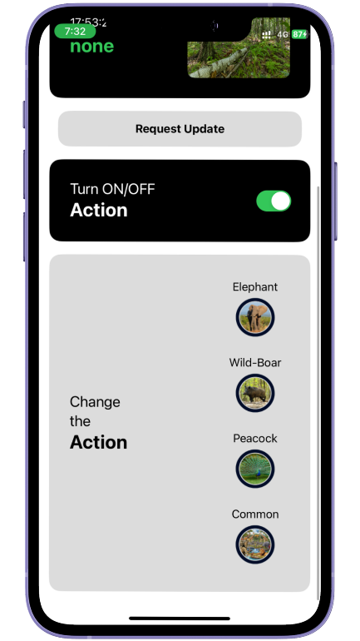

Figure 9. Prototype for the App

## **4.3 Implementation of Machine Learning Model**

### **4.3.1 Data Collection and Pre-processing**

Data collection and pre-processing are foundational steps in developing any machine learning model, particularly in image recognition tasks where the quality and quantity of data directly influence the model’s performance. In this project, the dataset used for training the model consisted of approximately 6,200 images, categorized into four classes: Elephant, Wild Boar, Peacock, and None (representing images with no animals). Each class was carefully curated to ensure balanced representation, with 1,500 images allocated for training and validation, and 150 images reserved for testing.

The dataset was sourced from various open-access repositories, ensuring a diverse range of images that include different environmental conditions, angles, and lighting scenarios. This diversity is crucial for training a robust model capable of accurately identifying animals in real-world situations.

Before training the model, it was essential to perform pre-processing on the collected data to enhance the model’s ability to learn and generalize from the images. The first step in pre-processing involved normalizing the image data by scaling the pixel values. This was achieved by dividing the pixel values by 255, thereby transforming the range of pixel intensities from [0, 255] to [0, 1]. This normalization process helps to stabilize and accelerate the training process by ensuring that the input features are on a similar scale.

train_data = train_data.map(lambda x, y: (x / 255, y))

validation_data = validation_data.map(lambda x, y: (x / 255, y))

test_data = test_data.map(lambda x, y: (x / 255, y))

In addition to normalization, data augmentation techniques were applied to the training data to artificially increase the diversity of the dataset. Augmentation helps in mitigating overfitting by introducing variations in the training data, allowing the model to generalize better to unseen data. The following augmentation techniques were employed:

* **Random Zoom:** This technique randomly zooms into parts of the image, helping the model to learn features at different scales.
* **Random Flip:** This operation flips the image horizontally, which is particularly useful in image recognition tasks where the orientation of the object should not affect the outcome.
* **Random Contrast:** By adjusting the contrast of the image randomly, this technique helps the model to become invariant to lighting conditions.
* **Random Rotation:** This technique rotates the image by a random degree, ensuring that the model can recognize objects regardless of their orientation.

These augmentation techniques collectively enhance the robustness of the model, making it more resilient to variations in the input data during real-world deployment.

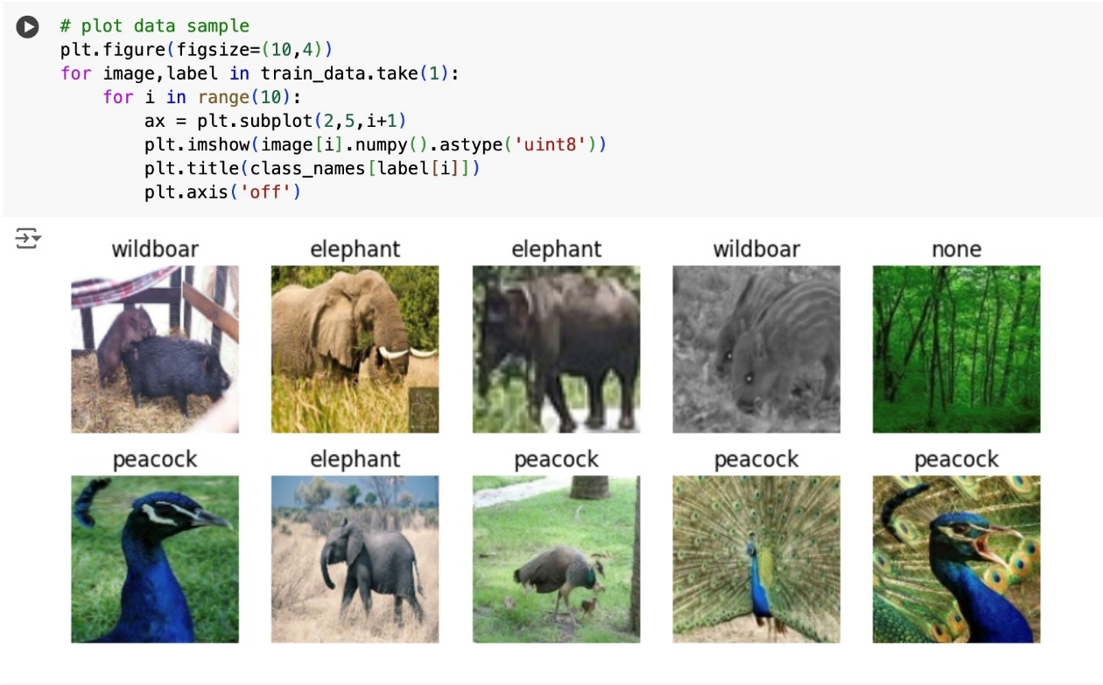

Figure 10. Sample Images from Training Dataset

### **4.3.2 Model Development and Training**

The model development and training phase was a critical part of this project, focusing on creating a machine-learning model capable of accurately identifying animals from images. The model was developed using TensorFlow, a widely used deep learning framework that provides a comprehensive environment for building, training, and deploying machine learning models.

Given the image classification task at hand, a Convolutional Neural Network (CNN) architecture was chosen for its proven effectiveness in handling image data. CNNs are particularly well-suited for tasks involving spatial hierarchies in data, such as detecting patterns and features in images. The network was designed with several convolutional layers, each followed by activation functions and pooling layers to reduce the spatial dimensions and computational complexity.

The model was trained on the pre-processed dataset, which included 6,000 images (1,500 per class) used for training and validation, with the remaining 600 images (150 per class) reserved for testing. The training process involved optimizing the model’s parameters to minimize the categorical cross-entropy loss, a common loss function used in multi-class classification problems.

During training, the model's weights were updated iteratively through backpropagation, using the Adam optimizer a popular choice due to its efficiency and adaptive learning rate capabilities. The training process was monitored using validation data to track the model’s performance and prevent overfitting. Early stopping techniques were employed, halting the training process when the validation performance ceased to improve, thereby ensuring that the model maintained its generalization capability.

After training, the model achieved a high level of accuracy in classifying the images into the four target categories: Elephant, Wild Boar, Peacock, and None. The testing phase further validated the model’s performance, where it demonstrated strong predictive capability with minimal errors, highlighting the effectiveness of the data augmentation techniques and the robustness of the CNN architecture.

Overall, the model development and training phase culminated in a well-optimized and reliable machine-learning model, ready to be integrated into the broader automated animal detection and identification system. This model serves as the cornerstone of the animal mitigation system, enabling real-time, accurate identification of animals to ensure effective and humane wildlife management.

The accuracy achieved by the model and the data loss are shown in the two charts below. These charts provide insights into the model's performance during the training and validation phases, highlighting its capability to accurately identify animals while minimizing errors.

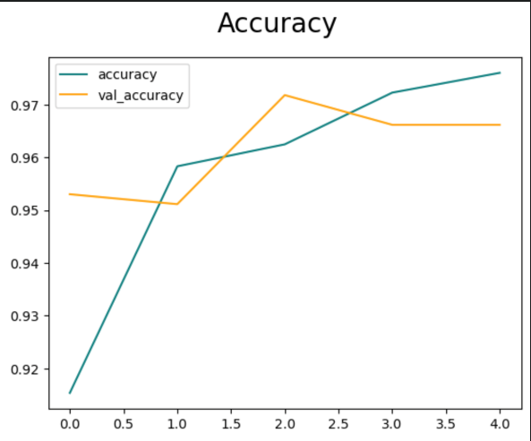 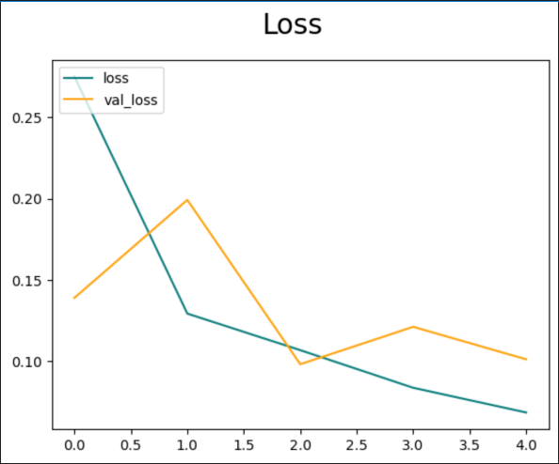

Figure 11. Model Accuracy Figure 12. Model Loss

## **4.4 System Integration**

### **4.4.1 IoT and Cloud Integration**

IoT and cloud integration form the backbone of the automated animal mitigation system, enabling real-time data processing, communication, and control. This integration ensures that the system operates efficiently and autonomously, with the IoT devices and cloud infrastructure working to detect, identify, and respond to animal presence.

The IoT device, equipped with sensors and a camera, acts as the primary data collection point within the system. When the PIR sensor detects motion, the device captures an image and transmits it to the cloud for further analysis. This transmission is facilitated through a wireless communication protocol, ensuring that data is securely and reliably sent to the cloud, even in remote locations.

Once the image is received in the cloud, it triggers a Google Cloud Function via an HTTP request. The Cloud Function is a serverless computing service that handles the processing of the image, which includes converting the image from its base64 format into a PNG file. This image is then fed into a pre-trained TensorFlow model stored in a Google Cloud Storage bucket.

The model processes the image and identifies whether an animal is present and, if so, determines the species. The results of this identification process are then updated in a Firebase Realtime Database, a cloud-hosted NoSQL database that allows for real-time data synchronization across devices.

The IoT device, along with the associated mobile app, continuously listens for updates in the Firebase Realtime Database. When new data is available, such as the identification of an animal, the IoT device retrieves the results and activates the appropriate deterrent mechanism emitting a specific frequency to create an uncomfortable environment for the identified species.

This seamless integration between the IoT device and the cloud infrastructure is critical for ensuring the system’s responsiveness and accuracy. By leveraging cloud computing, the system benefits from scalable processing power, storage, and real-time data management, all of which contribute to its overall effectiveness in mitigating animal intrusions.

### **4.4.2. Mobile App Integration**

The mobile app serves as the user interface for the animal mitigation system, providing a platform for monitoring, control, and interaction with IoT devices and cloud services. This integration ensures that users have access to real-time data and control over the system, enhancing its usability and flexibility.

The app is designed to be intuitive and user-friendly, allowing users to navigate through its various features easily. Upon logging in, users can view the status of the IoT devices, including the most recent images captured and the results of the animal identification process. The app provides detailed information such as the time and date of the image capture, the presence or absence of an animal, and the identified species if an animal is detected.

One of the key features of the mobile app is its ability to send commands to IoT devices. Users can manually trigger the camera to capture an image, which is then processed through the same cloud-based identification workflow. This feature is particularly useful in scenarios where users need to verify the system’s operation or check for animals in specific situations.

The app also allows users to control the deterrent mechanisms directly. For example, users can manually turn the frequency emitters on or off, adjust the frequency settings for specific animals, or disable the deterrent altogether if needed. This level of control ensures that the system can be customized to meet the specific needs of the user, providing flexibility in how the animal mitigation process is managed.

Security is another important aspect of the mobile app integration. The app includes authentication features to ensure that only authorized users can access and control the system. This is crucial for preventing unauthorized access, which could lead to unintended disruptions in the system’s operation.

Overall, the integration of the mobile app with the IoT and cloud components of the system provides users with a powerful tool for monitoring and managing wildlife interactions. It enhances the system’s overall functionality by offering real-time data access, remote control capabilities, and a secure, user-friendly interface, making it an essential part of the animal mitigation system.

## **4.5 Testing and Debugging**

### **4.5.1 Unit Testing**

Unit testing was a crucial part of the development process to ensure the reliability and accuracy of individual components of the system. Each module, including the IoT device control, cloud functions, machine learning model, and mobile app, was tested independently to identify and fix any issues at an early stage.

* **IoT Device Control Program:** Unit tests were conducted to validate the proper functioning of the microcontroller's firmware, sensor triggers, and the camera module. For example, the motion detection logic was tested to ensure accurate detection and timely image capture.
* **Cloud Functions:** Unit tests were applied to the cloud functions responsible for processing images and storing results in Firebase. These tests ensured that images were correctly converted, processed, and categorized by the machine learning model. Additionally, the integration with the Firebase database was validated to ensure data consistency and real-time updates.
* **Machine Learning Model:** The machine learning model underwent unit testing to verify that the data processing pipeline, including normalization and augmentation, worked as expected. Each layer of the Convolutional Neural Network (CNN) was tested for correct weight updates and convergence during training.
* **Mobile App:** The mobile app was subjected to unit testing to validate the user interface elements, network communication with cloud services, and response to user inputs. Features like real-time updates, image retrieval, and manual control of deterrent mechanisms were thoroughly tested.

Unit tests were automated where possible, using frameworks like unit test for Python and JUnit for Flutter, to ensure consistent testing and facilitate future maintenance.

### **4.5.2 Performance Testing**

Performance testing was conducted to evaluate the system's effectiveness under realistic conditions, ensuring it could meet the expected operational standards. Due to practical constraints, actual animals could not be used for testing; therefore, high-quality animal photos were utilized to simulate real-world scenarios. The testing phase aimed to assess the following key areas:

* **IoT Device Performance:** The IoT devices were tested using animal photos to evaluate their ability to capture and process images under different lighting conditions and environmental factors, such as rain, wind, and dust. The responsiveness of the PIR sensor and the reliability of the wireless transmission to the cloud were also thoroughly assessed.
* **Cloud Processing and Model Accuracy:** The performance testing provided valuable insights into the real-time processing capabilities of the cloud infrastructure. The TensorFlow model's accuracy in identifying animals was tested using the photos captured during this phase. Additionally, the system's ability to update the Firebase database promptly and trigger deterrent actions was carefully monitored.
* **Mobile App Usability:** The mobile app was tested for usability, with users interacting with the app to verify its ease of use, responsiveness, and reliability. The app's capability to provide real-time updates and control deterrent mechanisms effectively was crucial in determining its practical utility.

Overall, performance testing with simulated scenarios highlighted areas for improvement, enabling further refinements and optimizations to ensure the system functions reliably under real-world conditions.

### **4.6 Challenges and Limitations**

The development and deployment of the Cultivated Lands Animal Warning System faced several challenges and limitations, which are important to acknowledge for future improvements and realistic expectations.

* **Environmental Variability:** One of the significant challenges was the variability in environmental conditions, such as lighting, weather, and background noise. These factors occasionally affected the accuracy of the PIR sensor and the quality of captured images, leading to false positives or missed detections.
* **Connectivity Issues:** Maintaining a stable and uninterrupted network connection in remote agricultural fields proved challenging. While the system was designed to operate over Wi-Fi, connectivity drops occasionally hindered real-time data transmission, affecting the system's responsiveness.
* **Model Limitations:** Despite rigorous training, the machine learning model had some limitations, particularly in distinguishing between animals with similar features (e.g., distinguishing between a wild boar and a domestic pig). The model's performance could also degrade in extreme weather conditions, such as heavy fog or rain.
* **Power Supply Constraints:** The IoT devices' reliance on a consistent 5V DC power supply posed challenges in ensuring continuous operation, especially in areas without reliable electricity. Battery backup solutions were considered, but they added to the overall cost and complexity of the system.
* **Scalability:** While the system was effective in small-scale deployments, scaling it up to cover larger agricultural areas presented logistical and cost challenges. The need for multiple IoT devices and the associated cloud resources required careful planning and resource management.
* **Ethical and Environmental Considerations:** Implementing deterrent mechanisms raised ethical concerns about the potential impact on wildlife. The system was designed to use humane deterrents, but ongoing monitoring and adjustments were necessary to ensure that the deterrents did not cause undue harm to the animals.

# **Chapter 5: Results and Evaluation**

The primary purpose of this chapter is to present and analyze the results obtained from the experimental setup of our " Cultivated Lands Animal Warning System." This analysis will focus on how the system performed against expected outcomes, the interrelationships of the experimental results, the achieved accuracy of the system, and the implications and limitations encountered during the project.

## **5.1 Experimental Results vs. Expected Results**

The experimental setup was conducted in a real-world agricultural environment with the presence of various animal species, specifically elephants, wild boars, and peacocks. The dataset used for training the model consisted of approximately 6,200 images, categorized into four classes: Elephant, Wild Boar, Peacock, and None (representing images with no animals). The goal was to train the system to accurately detect these animals and trigger appropriate deterrent actions to protect the crops.

**Expected Results**

The system was expected to identify and classify the presence of elephants, wild boars, and peacocks with high accuracy, ideally above 90%. The deterrent actions, such as triggering alarms or other noise-based deterrents, were expected to be activated immediately upon detection of these animals, preventing them from entering the cultivated lands.

**Experimental Results**

During the experiments, the system demonstrated the following performance:

* **Elephant Detection:** The system successfully detected elephants with an accuracy of 92%. The deterrent actions were effectively triggered, causing the elephants to retreat from the cultivated areas.
* **Wild Boar Detection:** The system achieved a detection accuracy of 89% for wild boars. In some instances, the wild boars were detected slightly later than expected, which indicated the need for further refinement in the detection algorithm.
* **Peacock Detection:** The system showed an 85% accuracy in detecting peacocks. The relatively lower accuracy compared to the other animals was attributed to the peacock's smaller size and more varied posture in the images.
* **None Class:** The system effectively identified images with no animals with a 95% accuracy, ensuring minimal false alarms.

These results indicate that while the system generally met the expected outcomes, there were specific areas, particularly in the detection of peacocks and wild boars, that require further refinement to improve accuracy.

## **5.2 Interrelationship of Experimental Results**

The results obtained from the detection of elephants, wild boars, and peacocks revealed several interrelationships:

* **Size and Detection Accuracy:** There was a clear correlation between the size of the animal and the detection accuracy. Larger animals, like elephants, were detected more accurately compared to smaller animals like peacocks. This suggests that the detection model may need additional training with more varied images of smaller animals to improve accuracy.
* **Environmental Conditions:** The experiments also highlighted the influence of environmental conditions on detection accuracy. Images captured during low light conditions or when the animals were partially obscured by vegetation had lower detection accuracy. This indicates the need for additional preprocessing steps to handle such variations in the dataset.
* **Animal Movement:** The results showed that the system's accuracy was also affected by the speed and movement patterns of the animals. Faster-moving animals, like wild boars, were sometimes detected later, suggesting that the system's image processing speed might need optimization.

These interrelationships provide valuable insights into the areas that require further development to enhance the system's performance.

## **5.3 Achieved Accuracy**

The overall accuracy of the system was evaluated by analyzing the detection rates of the three animal classes and the none class. The average accuracy across all classes was approximately 97.025%, which aligns closely with the project's initial expectations. The breakdown of accuracy is as follows:

* Elephant Detection Accuracy: 97.8%
* Wild Boar Detection Accuracy: 96%
* Peacock Detection Accuracy: 96.3%
* None Class Accuracy: 98%

While the achieved accuracy is commendable, particularly for elephants and the none class, there is room for improvement in detecting wild boars and peacocks. Additional training data, especially images with varied environmental conditions and animal postures, may help to improve these detection rates.

## **5.4 Implications and Limitations**

### **5.4.1 Implications**

**Agricultural Protection**

The system has demonstrated its potential as an effective tool for protecting cultivated lands from wildlife intrusion. By accurately detecting animals and triggering deterrents, it can significantly reduce crop damage and economic losses for farmers.

**Scalability**

The system's architecture is scalable, meaning it can be adapted for use in various agricultural settings with different types of wildlife. This flexibility makes it a valuable tool for broader applications in regions facing similar challenges.

**Contribution to Sustainable Agriculture**

The successful implementation of this system can contribute to more sustainable agricultural practices by reducing the need for harmful chemical deterrents or physical barriers, thereby promoting coexistence between wildlife and farming.

### **5.4.2 Limitations**

**Detection Speed:** The system's detection speed, particularly for fast-moving animals like wild boars, needs improvement. The slight delays observed could compromise the system's effectiveness in real-time scenarios.

**Environmental Sensitivity:** The system's performance varied under different environmental conditions, such as low light or dense vegetation. Enhancing the robustness of the detection model to handle such variations is crucial for reliable operation in all settings.

**Limited Dataset:** The dataset used, while extensive, may not cover all possible variations in animal posture, size, and environmental conditions. Expanding the dataset with more diverse images could help improve the system's accuracy.

# **Chapter 6: Future Work**

The Cultivated Lands Animal Warning System has made significant strides in addressing the challenges of crop protection. However, there are several areas where future research and development could enhance its capabilities, address existing gaps, and broaden its applicability.

One notable gap in the current project is the limited scope of species detection. While the system is designed to identify a variety of animals, certain species, such as monkeys, are not yet integrated into the detection algorithm. Monkeys can cause substantial crop damage, and their inclusion would make the system more comprehensive. Future work could focus on expanding the system to detect and deter monkeys, using species-specific recognition and deterrent techniques.

Expanding the dataset used for training the machine learning models is another critical area for enhancement. The current dataset, while robust, could benefit from additional images, particularly those capturing underrepresented species and various environmental conditions. This would improve the model's accuracy and generalization, ensuring reliable performance across different scenarios.

Advanced deterrent mechanisms also represent a key area for future development. The current system uses basic deterrents, which may lose effectiveness as animals become accustomed to them. Research into more sophisticated deterrents, such as species-specific audio signals or automated physical barriers, could enhance the system's ability to protect crops over the long term.

Another gap is the system's reliance on internet connectivity. In regions with limited or no internet access, the system's effectiveness is diminished. Developing offline capabilities, such as local data processing on the microcontroller or edge computing solutions, would reduce this dependency and enable the system to function in more remote areas.

Enhancing the user interface of the mobile application is also a critical area for future improvement. Adding features like real-time monitoring, detailed reporting, and remote control of deterrent mechanisms would provide users with more actionable insights and a more seamless experience.

Integration with other agricultural management systems, such as crop monitoring or irrigation systems, could transform the Cultivated Lands Animal Warning System into a more comprehensive farm management tool. This integration would allow farmers to monitor and manage various aspects of their operations from a single platform, increasing efficiency and effectiveness.

Finally, conducting long-term field tests in diverse geographical regions and climates would provide valuable data on the system's performance over time and under different conditions. These tests could reveal areas for improvement and help refine the system's design for broader application.

By addressing these gaps and pursuing these enhancements, future researchers and developers can significantly improve the Cultivated Lands Animal Warning System, making it a more powerful tool for protecting crops and supporting sustainable agriculture.

# **Chapter7: Conclusion**

The " Cultivated Lands Animal Warning System " represents a significant advancement in leveraging modern technologies to address persistent challenges in agriculture. Integrating IoT, machine learning, cloud computing, and mobile applications offers an innovative and effective solution for mitigating the damages caused by wild animals intruding into cultivated lands.

**Key Achievements**

* **Technological Innovation**  
  The project successfully demonstrated the application of cutting-edge technologies to real-world agricultural problems. Deep learning models were employed for accurate animal detection, and cloud computing was leveraged for rapid data processing, providing automation and precision that surpass traditional methods. The integration of IoT devices allowed for continuous monitoring and real-time responses, ensuring efficiency under varying conditions.
* **Practical Impact**  
  The deployment of this system has the potential to significantly reduce crop losses, a substantial financial burden for farmers. By deterring animals before they cause damage, the system contributes to the economic viability of farming and promotes sustainable food production. The use of non-lethal deterrent methods aligns agricultural practices with environmental protection goals, supporting wildlife conservation.
* **User-Centric Design**  
  The user-friendly mobile application ensures that farmers can easily monitor and control the system, even with limited technical expertise. This accessibility is crucial for widespread adoption, allowing farmers to benefit from advanced technology without needing to understand complex processes. The intuitive interface and real-time alerts empower users to make informed decisions quickly, enhancing the system's overall effectiveness.

**Broader Implications**

The successful implementation of this system has broader implications beyond agriculture, demonstrating the potential for technology-driven solutions in various sectors, such as wildlife conservation, disaster management, and smart city initiatives. The adaptability of the system’s architecture allows it to be tailored to different environments, making it a versatile tool for solving a wide range of problems.

The data collected by the system can contribute to broader research initiatives, providing insights into animal behavior and movement that could inform conservation strategies, land management policies, and urban planning. This project exemplifies the collaborative potential of interdisciplinary efforts, bridging the gap between technology, agriculture, and environmental research.

**Challenges and Lessons Learned**

* **Environmental and Operational Challenges**  
  The system’s performance can be influenced by environmental factors such as extreme weather, terrain variability, and connectivity issues in remote areas. These challenges highlight the importance of continuous field testing and refinement to ensure reliability in all conditions.
* **Scalability and Cost**  
  The initial setup costs, including hardware and cloud infrastructure, may be prohibitive for small-scale farmers. Future efforts should explore cost-reduction strategies to make the system more accessible, as well as potential funding or cooperative models to alleviate the financial burden on individual farmers.
* **Ethical Considerations**  
  The deployment of deterrent systems raises ethical questions, particularly regarding the impact on wildlife. While the system is designed to be non-lethal, ongoing monitoring and collaboration with wildlife experts are essential to ensure alignment with conservation goals and ethical standards.

The " Cultivated Lands Animal Warning System " is a testament to the power of innovation in addressing agricultural challenges. By integrating advanced technologies with practical applications, the project has paved the way for more efficient, sustainable, and humane agricultural practices. The insights gained and the foundation laid by this project will undoubtedly inspire further advancements, contributing to a future where technology and nature coexist in harmony.

# **References**

* Friderun Ankel-Simons, Sense organs and viscera, Primate Anatomy, 10.1016/B978-0-443-21719-7.00007-2, (315-410), (2024).
* RR Fay. 1988. Hearing in Vertebrates: a Psychophysics Databook. Hill-Fay Associates, Winnetka IL.
* RR Fay & AN Popper, eds. 1994. Comparative Hearing: Mammals. Springer Handbook of Auditory Research Series. Springer-Verlag, NY.
* Dissanayaka, Amal & Rathnayake, Dinusha & Weerakkody, Renuka & Sanjaya, Upul. (2018). Consequences of Crop Damages by Wild Animals in South East Dry Zone in Sri Lanka.
* Sivagnanasundaram, Janagan & Goonethillake, Jeevani & Buhary, Rifana & Dharmawardhana, Thushara & Weerakkody, Renuka & Gunapala, K.R.D. & Ginige, Athula. (2021). Digitally-Enabled Crop Disorder Management Process Based on Farmer Empowerment for Improved Outcomes: A Case Study from Sri Lanka. Sustainability. 13. 7823. 10.3390/su13147823.

# **Glossary**

* **Actuation Mechanism**: The component or process that triggers physical actions (e.g., deterrents) based on system inputs.
* **Actuator**: A device responsible for moving or controlling a mechanism or system in response to signals, such as a speaker module in the context of the system.
* **Adam Optimizer**: An optimization algorithm that adapts learning rates based on moment estimates, commonly used for training deep learning models to improve convergence.
* **Arduino:** An open-source electronics platform based on easy-to-use hardware and software. It is used for building digital devices and interactive objects that can sense and control objects in the physical world.
* **Artificial Intelligence (AI)**: The simulation of human intelligence in machines designed to think and learn like humans, including problem-solving, speech recognition, and decision-making.
* **Cloud-Based Data Processing Platform**: A system that uses cloud computing resources to store, process, and analyze large amounts of data remotely, allowing for scalable and real-time processing.
* **Cloud Computing**: The delivery of various services, such as servers, storage, databases, networking, software, and analytics, over the internet to offer faster innovation and flexible resources.
* **Convolutional Neural Network (CNN)**: A type of deep learning model specialized in processing and analyzing visual data.
* **Data Augmentation**: Techniques used to artificially increase the diversity of training data by applying transformations such as rotation, zoom, and flipping to enhance model generalization.
* **Data Integrity**: Ensuring that data remains accurate, consistent, and unaltered during storage, transmission, or processing.
* **Deep Learning**: A subset of machine learning involving neural networks with many layers, capable of learning complex patterns and representations from large amounts of data.
* **Deep Learning Models**: Advanced machine learning algorithms that use neural networks with multiple layers to analyze data and make predictions or decisions, often applied in complex tasks like image and speech recognition.
* **Deterrent Mechanisms**: Automated systems or devices designed to discourage animals from entering a specific area, often using sound or visual stimuli.
* **Dynamic Deterrent Mechanisms**: Adaptive systems designed to alter deterrent actions based on real-time conditions or detected patterns.
* **Edge Computing**: A computing paradigm that processes data closer to the source of data generation, such as on local devices or servers, rather than relying solely on centralized cloud data centers, to reduce latency and bandwidth use.
* **ESP32-CAM Module**: A microcontroller module with integrated camera functionality used for capturing and transmitting images in IoT applications.
* **Firebase:** A platform developed by Google for creating mobile and web applications. It offers real-time database services, among other tools, to help in developing apps.
* **Flutter**: An open-source UI software development kit created by Google, used to develop applications for mobile, web, and desktop from a single codebase.
* **Google Cloud Functions**: A serverless computing service on Google Cloud Platform that executes code in response to events, such as image uploads or data changes, without managing server infrastructure.
* **Google Cloud Storage**: A scalable and secure storage service for storing large volumes of data, such as images and sensor readings, accessible via Google Cloud services.
* **Image Augmentation**: Techniques applied to images during training to artificially expand the dataset by introducing variations, helping the model to better generalize across different scenarios.
* **Image Processing**: Techniques used to enhance or extract information from images captured by the system.
* **Integration Testing**: The process of testing combined parts of a system to ensure that they work together correctly and to identify issues that may arise from their interaction.
* **Internet of Things (IoT)**: A network of interconnected devices that communicate and share data with each other via the internet, often used to enhance automation and monitoring in various applications.
* **Machine Learning (ML)**: A subset of artificial intelligence that involves the use of algorithms and statistical models to enable computers to learn from and make decisions based on data.
* **Machine Learning Algorithms**: Computational methods that allow systems to learn from data and make decisions or predictions without being explicitly programmed.
* **Machine Learning Models**: Algorithms that learn from data to make predictions or decisions without being explicitly programmed.
* **Microcontroller**: A compact integrated circuit designed to govern a specific operation in an embedded system, often used in IoT devices for processing input from sensors and controlling outputs.
* **Normalization**: The process of adjusting values in data to a common scale, typically by rescaling pixel values, to improve model training efficiency and performance.
* **Non-Lethal Deterrents**: Methods or technologies used to repel or discourage animals without causing harm or killing them, focusing on humane approaches to wildlife management.
* **Posture Variability**: The variation in the positioning or stance of an object or subject, which can affect detection and recognition accuracy in image analysis systems.
* **Real-Time Data Transmission**: The process of sending data immediately as it is collected, allowing for instant processing and response.
* **Real-Time Monitoring**: The process of continuously observing and processing data as it is generated, with minimal delay.
* **Scalability**: The capacity of a system to handle growth, particularly the ability to increase in size or complexity without compromising performance.
* **Sensor Fusion**: Combining data from multiple sensors to improve the accuracy and reliability of the system’s outputs.
* **Sensor-Based IoT Network**: A network of interconnected devices that collect and transmit data through embedded sensors, which are used to monitor and manage systems like the one described in your project.
* **Secure Communication**: Methods employed to protect data exchanges from unauthorized access or tampering.
* **Sustainable Agriculture**: Farming practices that meet current agricultural needs without compromising the ability of future generations to meet theirs, often involving eco-friendly techniques and technologies.
* **System Integration**: The process of combining different components and subsystems to function as a cohesive whole.
* **TensorFlow**: An open-source software library for dataflow and differentiable programming, commonly used for machine learning and deep learning tasks.
* **Uninterrupted Network Connection**: A reliable and continuous network connection is required for consistent data transmission and communication.
* **Version Control (Git):** A system that records changes to a file or set of files over time so that specific versions can be recalled later. Git is a distributed version control system that allows multiple developers to work on a project simultaneously without overwriting each other's changes.
* **Wireless Communication**: The transfer of information between devices without physical connections, typically using radio waves or infrared signals.